Group Alpha

Braden Baker

Logan Armstrong

Connor Dickinson

Colton Buster

Summary

This database is to manage some of the daily functions of a single hospital.

* Show which doctors have appointments with a patient
* track appointment information
* Store list of doctors that work in each department
* Store list of nurses that work in each department
* Store prescriptions, the patient it is prescribed for and the doctor that prescribed it
* Track if rooms in each department have a patient in them
* Store an emergency contact for each patient
* Store personal information about each doctor
* Store personal information about each nurse
* Store personal information about each patient

Out of scope data: inventory of medical supplies, inventory of prescriptions, financial information, insurance

In scope data: Patient information, appointment dates and times, doctor for each appointment,

Prescriptions, insurance type, department information, room information, nurse and doctor personal information

E-R Diagram

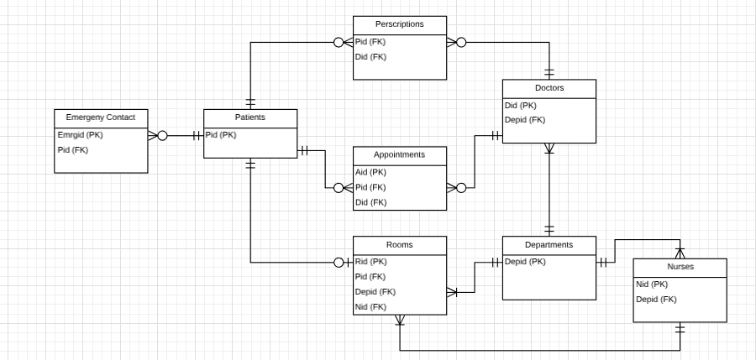

RDM:

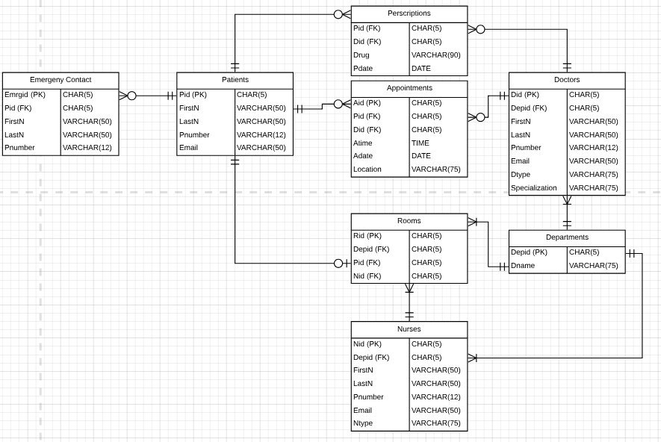

create table Patients (

Pid CHAR(5) not null,

FirstN VARCHAR(50) not null,

LastN VARCHAR(50) not null,

Pnumber VARCHAR(12),

Email VARCHAR(50),

PRIMARY KEY (Pid)

);

create table Emergency_Contact (

Emergid CHAR(5) not null,

Pid CHAR(5) not null,

FirstN VARCHAR(50) not null,

LastN VARCHAR(50) not null,

Pnumber VARCHAR(12) not null,

PRIMARY KEY (Emergid),

Foreign Key (Pid) References Patients(Pid)

);

create table Departments (

Depid CHAR(5) not null,

Dname VARCHAR(75) not null,

PRIMARY KEY (Depid)

);

create table Doctors (

Did CHAR(5) not null,

Depid CHAR(5) not null,

FirstN VARCHAR(50) not null,

LastN VARCHAR(50) not null,

Pnumber VARCHAR(12),

Email VARCHAR(50),

Dtype VARCHAR(75),

Specialization VARCHAR(75),

PRIMARY KEY (Did),

Foreign Key (Depid) References Departments(Depid)

);

create table Nurses(

Nid CHAR(5) not null,

Depid CHAR(5) not null,

FirstN VARCHAR(50) not null,

LastN VARCHAR(50) not null,

Pnumber VARCHAR(12),

Email VARCHAR(50),

Ntype VARCHAR(75),

PRIMARY KEY (Nid),

Foreign Key (Depid) References Departments(Depid)

);

create table Rooms(

Rid CHAR(5) not null,

Depid CHAR(5) not null,

Pid CHAR(5),

Nid CHAR(5),

PRIMARY KEY (Rid),

Foreign Key (Pid) References Patients (Pid),

Foreign Key (Depid) References Departments(Depid),

Foreign Key (Nid) References Nurses(Nid)

);

create table Prescriptions(

Pid CHAR(5) not null,

Did CHAR(5) not null,

Drug VARCHAR(90) not null,

Foreign Key (Pid) References Patients (Pid),

Foreign Key (Did) References Doctors(Did)

);

create table Appointments(

Aid CHAR(5) not null,

Pid CHAR(5) not null,

Did CHAR(5) not null,

Atime Time not null,

Adate DATE not null,

Location VARCHAR(75),

PRIMARY KEY (Aid),

Foreign Key (Pid) References Patients(Pid),

Foreign Key (Did) References Doctors(Did)

);

**Reports**

Shows patient names, department room is in, room number, and the nurse assigned to the room for patients that are rooms.

SELECT Patients.FirstN, Patients.LastN, Rooms.Depid, Rooms.Rid, Rooms.Nid FROM Patients INNER JOIN Rooms on Patients.Pid=Rooms.Pid;

Shows the number of prescriptions each doctor has prescribed, and there name and id.

SELECT count(Prescriptions.Did) AS PrescriptionsGiven, Doctors.FirstN, Doctors.LastN, Doctors.Did FROM Prescriptions, Doctors WHERE Doctors.Did=Prescriptions.Did GROUP BY Doctors.Did, Doctors.FirstN, Doctors.LastN;

Show which docotr is in each department

SELECT Doctors.FirstN, Doctors.LastN, Doctors.Depid FROM Doctors INNER JOIN Departments on Doctors.did= Doctors.did;

Dan Williams M0002  
Dan Williams M0002  
Dan Williams M0002  
Steve Miller M0001  
Steve Miller M0001  
Steve Miller M0001  
Sarah Jones M0003  
Sarah Jones M0003  
Sarah Jones M0003

Show which nurse is what department

SELECT Nurses.FirstN, Nurses.LastN, Nurses.Depid FROM Nurses INNER JOIN Departments on Nurses.nid= Nurses.nid;

Rachel Moore M0002  
Rachel Moore M0002  
Rachel Moore M0002  
Katy Bell M0001  
Katy Bell M0001  
Katy Bell M0001  
Samantha Young M0003  
Samantha Young M0003  
Samantha Young M0003

Shows which doctor is assigned to which patient:

SELECT Doctors.LastN as Doctor , patients.lastn as Patient

FROM Doctors JOIN Departments on Doctors.depid= departments.depid

Join rooms on departments.depid = rooms.depid JOIN patients ON rooms.Pid = patients.pid;

Show each patients drug:

SELECT patients.lastn as Patient, prescriptions.drug

FROM patients JOIN prescriptions on patients.pid= prescriptions.pid

**Inserts**

**PATIENTS TABLE**

INSERT INTO Patients

VALUES ('P0012', 'John', 'Smith', '202-555-0106', '[jsmith@yahoo.com](mailto:jsmith@yahoo.com)')

INSERT INTO Patients

VALUES ('P0044', 'Michael', 'Wilson', '208-736-9100', '[mikew@gmail.com](mailto:mikew@gmail.com)')

INSERT INTO Patients

VALUES ('P0129', 'Brenda', 'Johnson', '360-807-3365', '[brendajohnson@hotmail.com](mailto:brendajohnson@hotmail.com)')

**EMERGENCY CONTACTS inserts**

VALUES ('E0018', 'P0044', 'Linda', 'Smith', '202-269-1183')

INSERT INTO Emergency_Contact

VALUES ('E0111', 'P0129', 'Jacob', 'Wilson', '208-721-9179')

INSERT INTO Emergency_Contact

VALUES ('E0012', 'P0012', 'Mark', 'Johnson', '360-451-1632')

**Department inserts**

insert into Departments (Depid, Dname)

VALUES ('M0001','Surgery')

insert into Departments (Depid, Dname)

VALUES ('M0002','Emergency Room')

insert into Departments (Depid, Dname)

VALUES ('M0003','Intensive Care Unit')

**DOCTORS TABLE**

INSERT INTO Doctors

VALUES ('D0001', 'M0002', 'Dan', 'Williams', '214-919-5893', 'drdwilliams@gmail.com', 'Family Physician', 'orthopedics')

INSERT INTO Doctors

VALUES ('D0002', 'M0001', 'Steve', 'Miller', '713-080-0071', 'smiller@gmail.com', 'Cardiologist', 'Clinical cardiac electrophysiology')

INSERT INTO Doctors

VALUES ('D0003', 'M0003', 'Sarah', 'Jones', '823-517-7410', 'drjones@gmail.com', 'Family Physician', 'orthopedics')

**NURSES TABLE**

INSERT INTO Nurses

VALUES ('N0001', 'M0002', 'Rachel', 'Moore', '343-986-0123', 'rmoore@gmail.com', 'Registered Nurse')

INSERT INTO Nurses

VALUES ('N0002', 'M0001', 'Katy', 'Bell', '123-456-7890', 'katyb@gmail.com', 'Operating Room Nurse')

INSERT INTO Nurses

VALUES ('N0003', 'M0003', 'Samantha', 'Young', '222-845-1900', 'syoung@gmail.com', 'Clinical Nurse Specialist')

**ROOMS TABLE**

INSERT INTO Rooms

VALUES ('R0130', 'M0001', 'P0044', 'N0002')

INSERT INTO Rooms

VALUES ('R0215','M0002', 'P0129', 'N0002')

INSERT INTO Rooms

VALUES ('R0419','M0003', 'P0012', 'N0003')

**PRESCRIPTIONS INSERTS**

INSERT INTO Prescriptions

VALUES ('P0044', 'D0001', 'Amphetamine', '10/14/2018')

INSERT INTO Prescriptions

VALUES ('P0044', 'D0001','Hydrocodone', '10/15/2018')

INSERT INTO Prescriptions

VALUES ('P0044', 'D0001','Amoxicillin', '10/17/2018')

INSERT INTO Prescriptions

VALUES ('P0129', 'D0002','Amoxicillin', '10/12/2018')

INSERT INTO Prescriptions

VALUES ('P0012', 'D0003','Amoxicillin', '10/14/2018')

**Appointments INSERTS**

INSERT INTO Appointments

VALUES ('A0001', 'P0044', 'D0001', '10/14/2018', '09:30:00', 'Waiting Area 1')

INSERT INTO Appointments

VALUES ('A0002', 'P0044', 'D0001', '10/15/2018', '12:00:00', 'Waiting Area 1')

INSERT INTO Appointments

VALUES ('A0003', 'P0044', 'D0001', '10/17/2018', '15:30:00', 'Waiting Area 2')

INSERT INTO Appointments

VALUES ('A0004', 'P0129', 'D0002', '10/12/2018', '16:00:00', 'Waiting Area 4')

INSERT INTO Appointments

VALUES ('A0005', 'P0012', 'D0003', '10/14/2018', '10:00:00', 'Waiting Area 2')

SELECT * FROM DEPARTMENTS;

SELECT * FROM Patients;

SELECT * FROM Nurses;

SELECT * FROM Doctors;

SELECT * FROM Rooms;

SELECT * FROM Prescriptions;

SELECT * FROM Emergency_Contact;

SELECT * FROM Appointments;